**QUIZ RESULTS**

**MODULE1: LOGISTIC REGRESSION**

|  |  |  |  |  |
| --- | --- | --- | --- | --- |
| **No.** | **Quiz title** | **Completion Status** | **Score** | **Coursera link** |
| 1 | Module1_Logistic Regression | Completed | 100% | [Quiz 1](https://www.coursera.org/learn/supervised-machine-learning-classification/assignment-submission/O3Im3/logistic-regression/view-feedback) |
| 2 | Module1_Logistic Regression Labs | Completed | 100% | [Quiz 2](https://www.coursera.org/learn/supervised-machine-learning-classification/assignment-submission/h1XAH/logistic-regression-labs/view-feedback) |
| 3 | Module1_Logistic Regression | Completed | 100% | [Quiz 3](https://www.coursera.org/learn/supervised-machine-learning-classification/assignment-submission/1gp9n/module-1-graded-quiz-logisitic-regression/view-feedback) |

# Module1_Logistic Regression

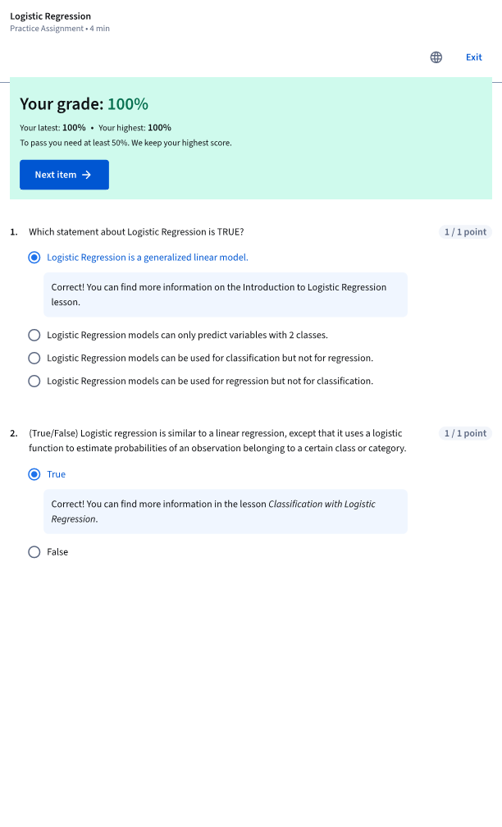

# Module1_Logistic Regression Labs

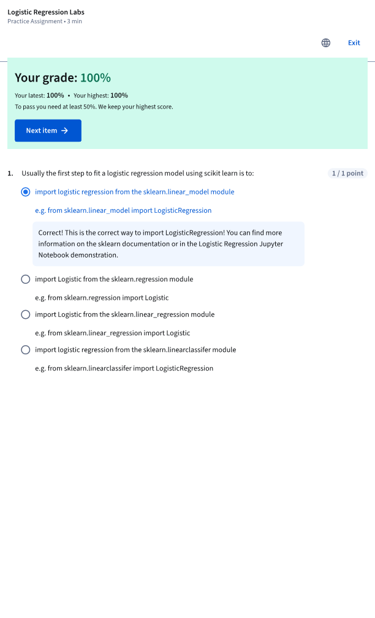

# Module1_ Logistic Regression

